Setup New Report
The steps for setting a report of this type are very similar to setting up any report or process in PeopleSoft. The only is difference is where you put your Crystal rpt file.

- Create Process Definition in PeopleSoft: PeopleTools, Process Scheduler, Process . Select the Add tab, and select the Crystal Native ODBC Process Type. Enter the name of your report.

Process Definition Tab
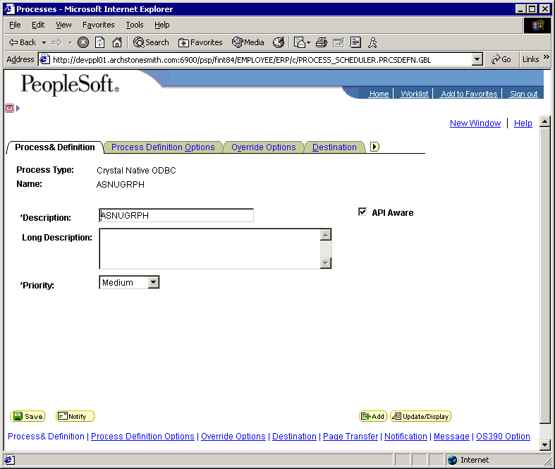

Make sure the API Aware box is checked.
Process Definition Options Tab
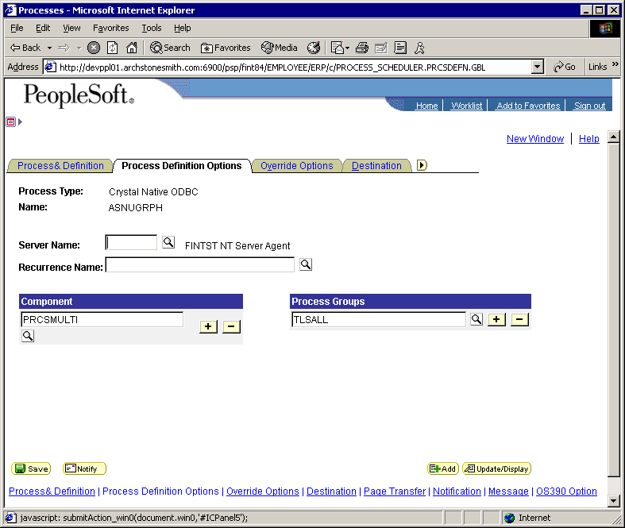

Enter the Component and Process Groups for your new report.
Override Options Tab
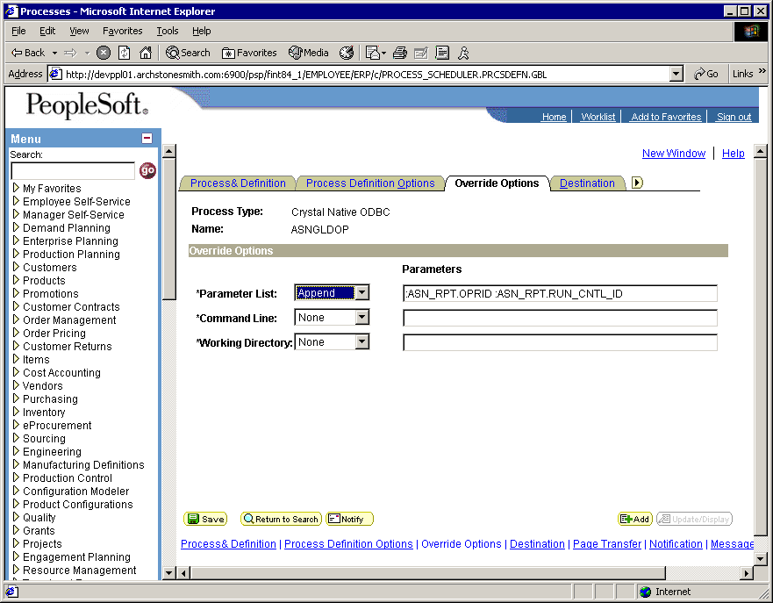
Any Parameters that need to be passed from your Run Control Page to the report are appended to the Parameter List here. Page fields are prefaced with ‘:’ OPRID and RUN_CNTRL_ID may be all that’s needed if your query joins to the Run Control Record within the report. (Make sure there is only one space between arguments) Keep in mind that there is a limit of 255 characters that can be saved in this field.
Destination Tab
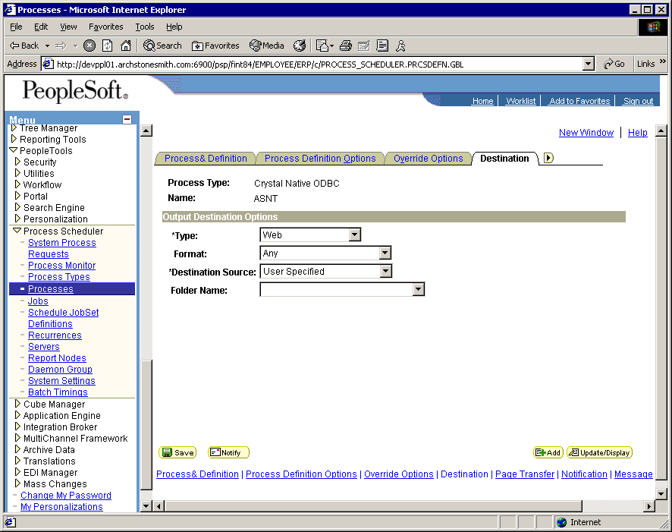
Select Type of Web and Format of Any. This will allow the user to select any formats that are defined for the Crystal Native ODBC type (Web / PDF or XLS).

All other tabs may be left to default. Use the notification tab to specify notification options upon report run completion.

Copy or create your new report in the %PS_HOME\crw\<Custom> directory, using %PS_HOME% from your Process Schedulers configuration.

Note: Had to apply a PeopleCode fix Destination Tab (this page) to allow the user to select the Type,…. It was grayed out originally. This was true for any Processes that were based on a Process Type, that was tied to the Generic Type Other. See PeopleCode PRCSDEFN.PRCSTYPE.FieldFormula, Function Validate Output Dest:
.
.
.
SQLExec("SELECT DISTINCT GENPRCSTYPE FROM PS_PRCSTYPEDEFN WHERE PRCSTYPE = :1", PRCSDEFN.PRCSTYPE, &GENPRCSTYPE);
If &GENPRCSTYPE = 1 /* SQR */ Or
&GENPRCSTYPE = 2 /* COBOL */ Or
&GENPRCSTYPE = 3 /* Crystal */ Or
&GENPRCSTYPE = 5 /* Application Engine */ Or
/* Chris Hennessy Added type 0 for Other here. This is a bug identified by PS, that prevents
* the selection of OutputDestType for Processes that use a Process Type Definition, that uses
* a Generic Process Type of other. HCI Crystal Native ODBC process type uses this.
*/
&GENPRCSTYPE = 0 /* Other */ Or
&GENPRCSTYPE = 7 /* nVision */ Then
Evaluate PRCSDEFN.OUTDESTTYPE
When "1"
.
.
.

Workaround if don’t implement PeopleCode fix:
Before creating your new Process Definition in PS, Update the Process Type Definition (Crystal Native ODBC) to use the Generic Type = Application Engine. When you have completed adding your new Process Definition, Update the Process Type Definition back to Other. This could affect any users that run a process of type Crystal Native ODBC while the Generic Process Type = Application Engine,… they will error.

Install custom Process Type Crystal Native ODBC
These steps will install the software necessary to use the custom Process Type.
- Copy %PS_HOME\bin\<custom> from development server to new PS_HOME\bin\<custom> directory.
- Modify the HCI_CRRUN.cfg file.
- RptConnect=server/Database/ID/Password (used to run report can be read-only)
- StatusConnect=server/Database/ID/Password (used to set Run Status, and write log messages)
- DebugFile=C:\Temp\HCI_CRRUN.log (Will be used with –D option)
- Define system ODBC on server for each of the Databases Referenced in #2.
- Install the .NET 1.1 Framework, by running dotnetfx.exe from the directory you just created. Do once per server.
- Install Crystal 8.5 for PeopleSoft from the PeopleSoft CD.
- Copy PS Project HCI_CRW_ODBC to database. (See Appendix A if you need to create from scratch). If you do not want to take the PeopleCode fix shown above, uncheck the copy box in the project before coping. This copy may be done from Database to Database using App Designer, or by importing the project from the file which is delivered in the directory you created in step 1; Project file is in the HCI_CRW_ODBC sub-directory. If importing from the file, you will also need to import the Messages defined for this Process Type. The dms and dat files to import using Datamover are in the same sub-directory.
- Add Process Output Type of Web for Process Type Other:
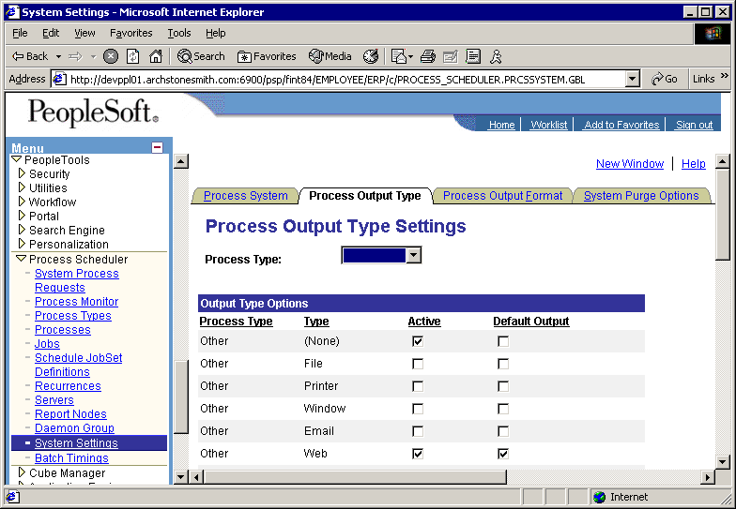
- Setup Output Formats for Other/Web:
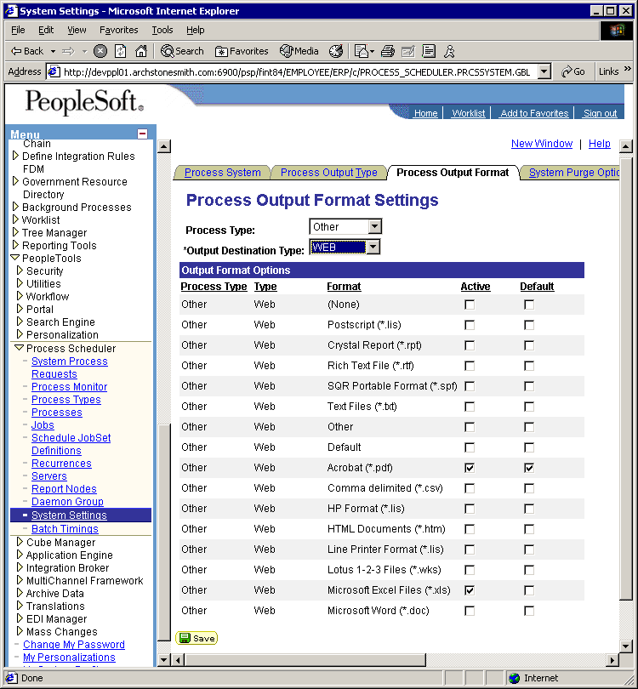
- Add new Process type to PSNT definition:
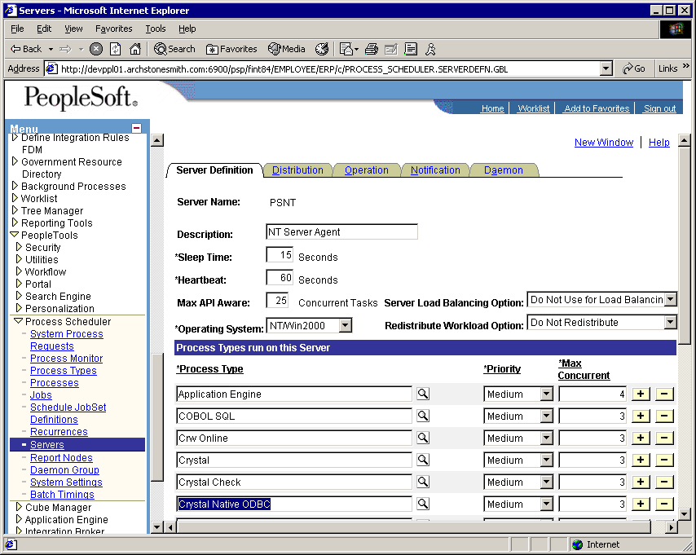
- Restart Process Scheduler that will be handling the new Process Type.

Copy %PS_HOME\crw\,custom> reports directory to new location

Issues
- May have problems with Cancel ?? Not sure if PRCS Scheduler will behave.
- Adding other PIA options to XLS and PDF?
- Had to have Bin Local?? Would have preferred to be able to have HCI_CRRUN code installed in one place, and run over network, but did not work that way upon first try,… did not pursue.

Appendix A: Defining Crystal Native ODBC Process Type manually.

You should not need to do this if you were able to import the Definition from another database, or a file. Here are is what it should look like if you need to do it manually.

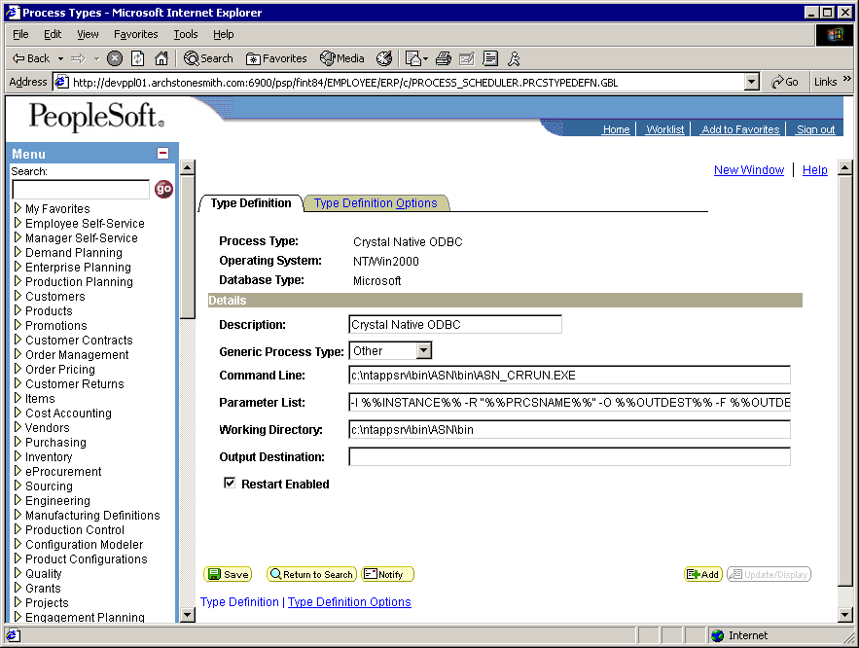

- Use Generic Process Type = Other.
- Command Line: %PS_HOME\bin\<custom>\bin\HCI_CRRUN.EXE
(ie. c:\ntappsrv\bin\<custom>\bin\HCI_CRRUN.EXE)
- Parameter Line: -I %%INSTANCE%% -R "%%PRCSNAME%%" -O %%OUTDEST%% -F %%OUTDESTFORMAT%% -D
(-D is optional, and will cause additional Debug output to be written to log file, and the Debug File as defined in the Configuration file)

